**GOOGLE SHEET PROJECT REQUIRMENTS OR DEPENDENCIES**

**PREQUESITES FOR PROJECT:**

**Step 1: Google Cloud Platform & make a new Project.**

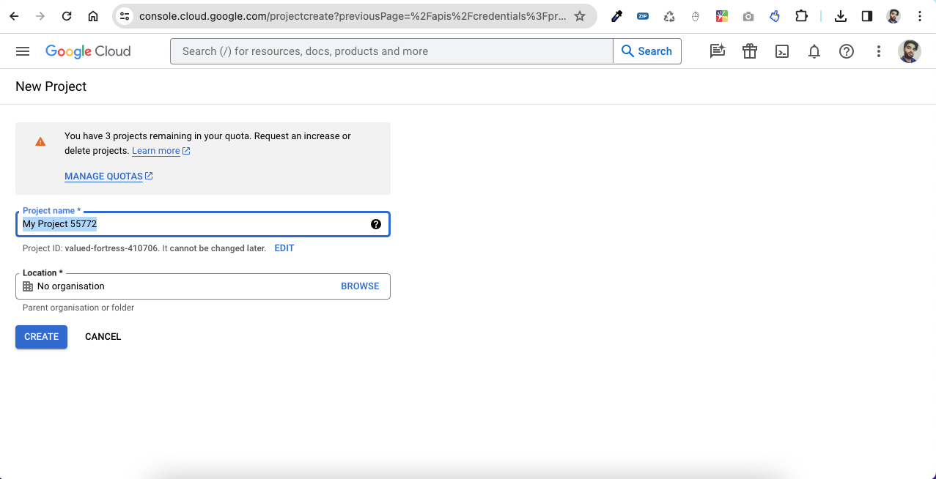

**Step 2:Go to market Place and Enable the Google Sheet API**

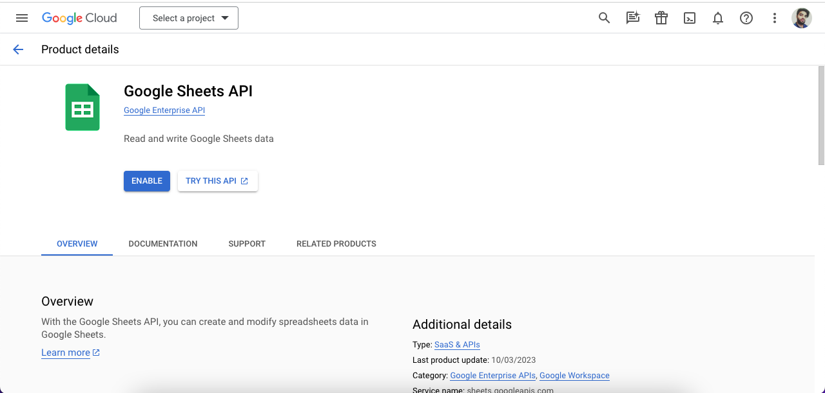

# Step3:After that select the project and go to “Credentials” tab from the left side of the menu bar

# 1)Create the "CREATE CREDENTIALS TAB" by “OAuth Client Id”

# 2)Select the “Web Application” and proceed to continue.

# 3)Provide scopes all api access.

# 4)Provide the App Details like Web URL and Developer Email details.

# 5)Go back to the dashboard area and continue the procedure.

# 

# Step 4: Go back to Credentials and make the new “CREATE CREDENTIALS” for an API KEY.

# 1)Create the api key too.

# 

# Step 5:Go to Credential and Create the Service Account

# 1)Put Services account details and continue the procedure

# 2)Grant this service account access the project as OWNER

# 3)Complete the Procedure by creating the credential for the services account.

# 4)Click on the Pencil Icon in Service account that you have created.

# 

# 5)Go to keys and create a create a JSON format and download it.

# 6)Save the JSON FILE that we need in our project.

**7)COPY THE SERVICES ACCOUNT 🡪Email “**[googlesheet@flash-direction-410514.iam.gserviceaccount.com](https://console.cloud.google.com/iam-admin/serviceaccounts/details/101942162654629722530;edit=true?previousPage=%2Fapis%2Fcredentials%3Fproject%3Dflash-direction-410514&project=flash-direction-410514)

# ” save it somewhere.

# Step 6: Make a Google Sheet that you need for this project.

# 1)Rename the Sheet Name to “GoogleSheetWorkSpace”

# 

# 2)Copy the “URL OF GOOGLE SHEET” that we need the sheet id in our project

# <https://docs.google.com/spreadsheets/d/1Ar9lVDV5eRBEO7SQLaTkrMj7EtAnZJimRCA9d-6nWHM/edit#gid=0>

# 3)SHARE it With the EMAIL that we saved Above and Provide him Editor access to read /write Google Sheet.

# 4)Then use my Code to Push the Data From External Api/Database/External System to Google Sheet and Good Luck..

# CONCLUSION:

# 1)FOR DEVELOPER END NEED ONLY 2 THINGS :

# i)JSON file only.

# ii)URL of Google Sheet & Name of Sheet Only.